Nandida Valsaraj

1. Installed Proton VPN

3. 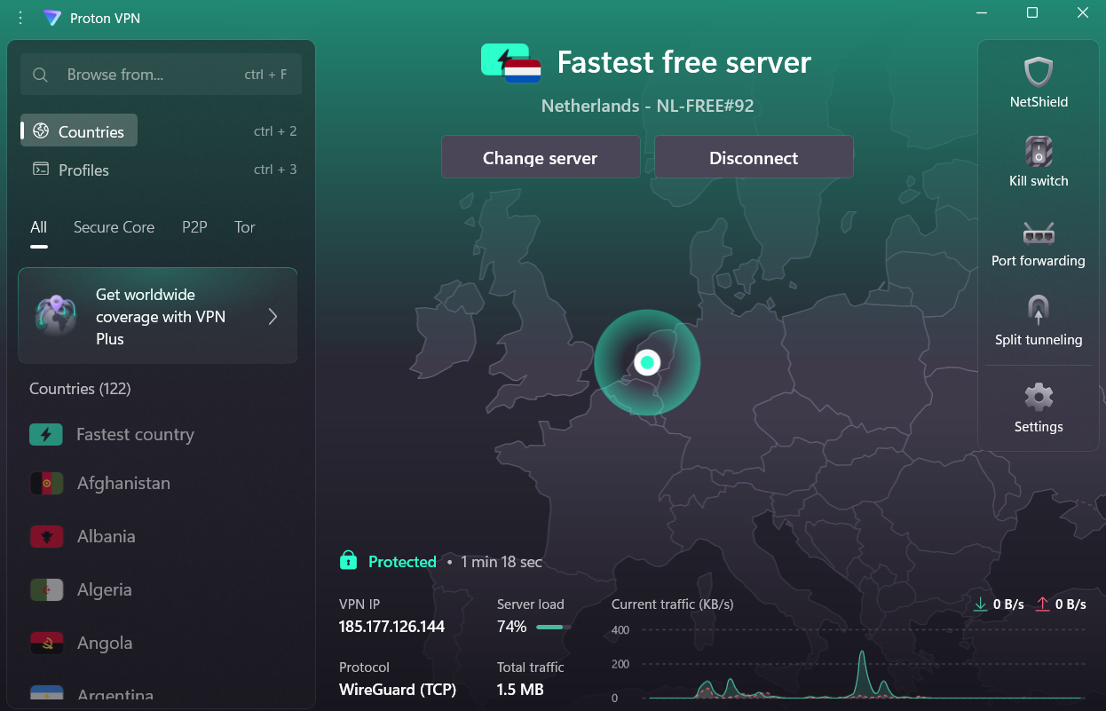

4.

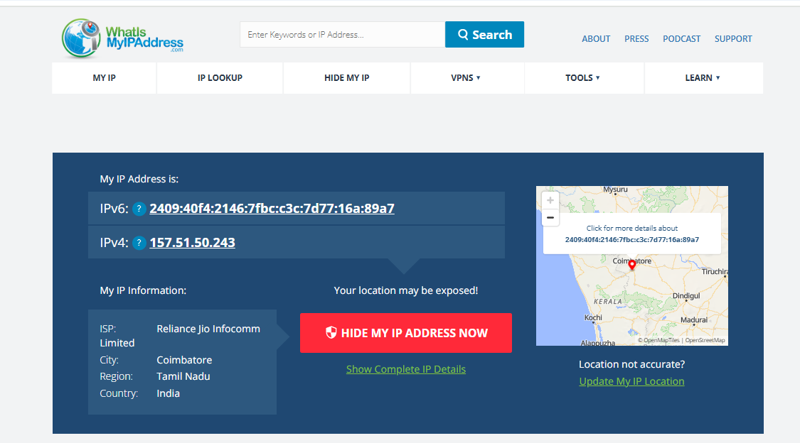

After connecting to VPN

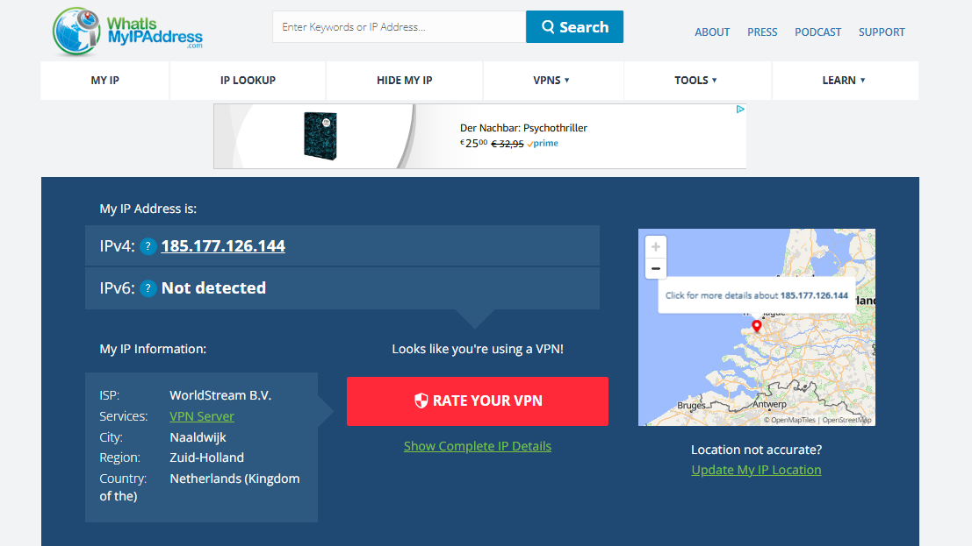

5.

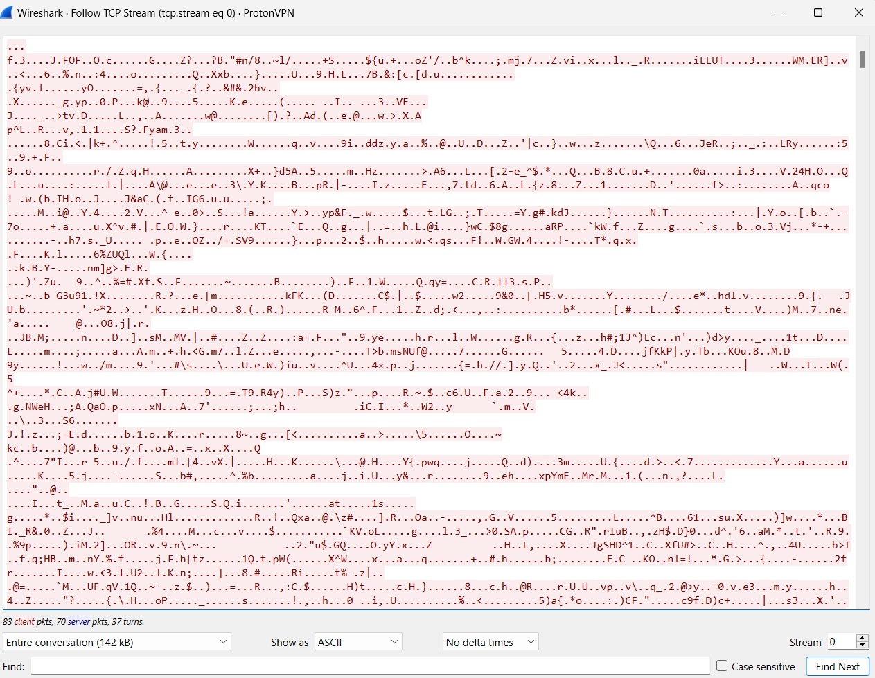

6.

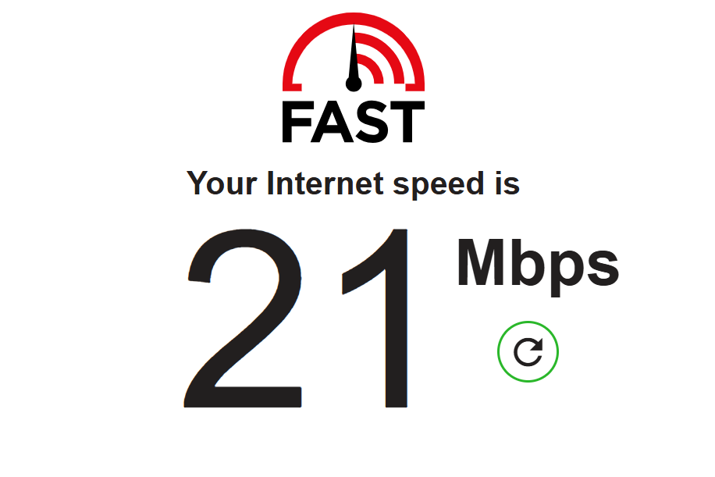

After Disconnecting VPN

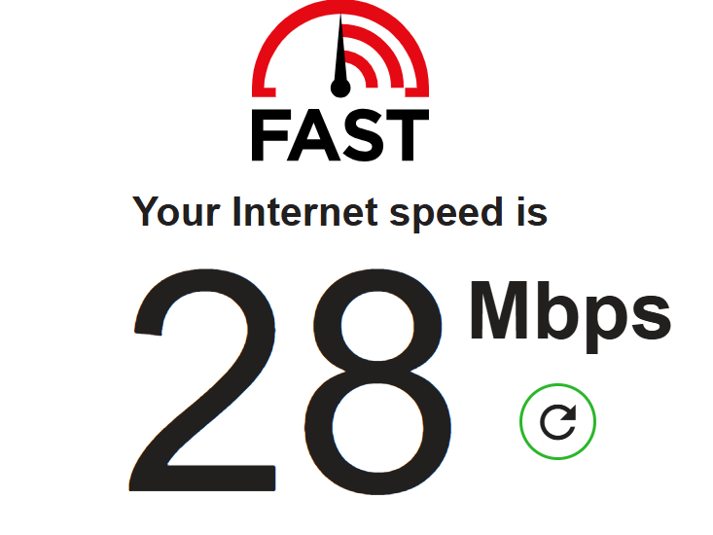

7. Proton VPN prioritizes user privacy through robust encryption and a range of security features. It uses strong encryption protocols like OpenVPN, IKEv2, and WireGuard, and implements features like perfect forward secrecy, DNS leak protection, and a kill switch. Uses the strongest encryption to protect your internet connection. This means we encrypt all your network traffic with AES-256, exchange keys with 4096-bit RSA, and use HMAC with SHA384 for message authentication.

8. Benefits

* **Privacy.** Using a VPN masks your real IP address and location, making your online activity more private.
* **Security.** A VPN creates an encrypted tunnel between your device and a [VPN server](https://nordvpn.com/servers/). This encryption helps protect sensitive information like passwords, credit card numbers, and sensitive data from hackers, especially when you’re using public Wi-Fi networks.
* **Access to home content from abroad.** VPNs allow you to access your home content from different regions by connecting to servers in those locations.
* **No more**[**bandwidth throttling**](https://nordvpn.com/blog/what-is-bandwidth-throttling/)**.** If your ISP is throttling your internet speed based on your activity (like watching online videos or gaming), a VPN can hide your activity type, potentially preventing this targeted slowdown and reducing lag in the process.

Limitations

* **Speed drop**: Due to encryption overhead and longer routing paths.
* **Limited features in free tiers**: Fewer servers, no streaming support.
* **Not 100% anonymous**: VPNs can still see your data unless zero-logs policy is truly enforced.
* **May not bypass all restrictions**: Some streaming services detect and block VPN IPs.